To avoid the hardcode url we can use loadbalanced annotation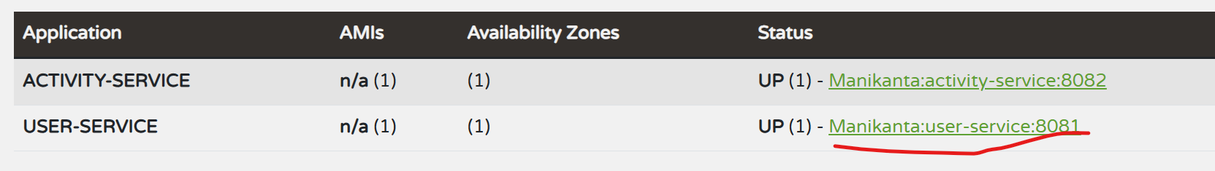

Instead hard code to have the service name directly so wherever/whichever irrespective of IP this server [Manikanta:user-service:8081](http://manikanta:8081/actuator/info) is running I have to just refer by the **USER-SERVICE** name

Via eureka server I’am going to connect to the UserService so that’s why I made use of @LoadBalanced with help of this annotation allows WebClient to resolve the service name via Eureka